**The feeder**

The feeder has as objective that it needs to somehow get the disks from the container onto the conveyor belt. This is needed for the use case “Sort unsorted disks”.

For the design of this feeder we had two competing designs. Both use the two hollow tubes stacked as a container. We chose to do this because they are completely reliable in containing the disks and because a new disk simply falls out if the bottom one is removed, they are very fast. Because the container is made off two big parts and some small parts to make them stack, the container is also very robust. It’s quite easy to put the disks into the big hole at the top, so user accessibility was very high. In short, the first solution that came to mind scored extremely high on all priorities and we looked no further.

The first design for the feeder consist of 3 important parts. First you have the container. The container drops a disk, which is then pushed onto the conveyor belt using a cam. A wall to the left of the container makes sure the disk is pushed up and not to the left.

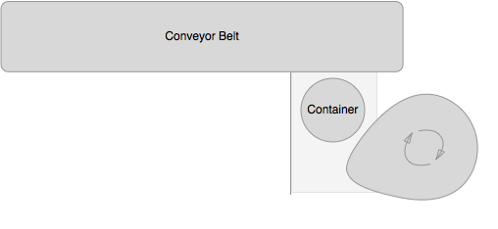

Our second design also consisted of a block that pushes the disk. To make this block move a lever attached to a wheel is used. Rotating the wheel makes the block move back and forth, pushing disks onto the conveyor belt.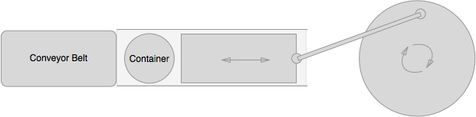

Both designs correctly implemented the use cases. To test which one would be better we build both and tested them. They scored the same on almost all top priorities. They were both completely reliable for instance. There was also no difference in speed, both would push a disk onto the conveyor belt with every turn of their wheels. Both did not hinder the user, so the good user accessibility of the container was unchanged. When we came to the last three priorities there were some differences making us choose the first design: It was easier to build, used less parts and was a lot more compact.